Project Design Phase-II
Data Flow Diagram & User Stories

Date | 31 January 2025
Team ID | LTVIP2026TMIDS66408
Project Name | Asset Management Portal
Maximum Marks | 4 Marks

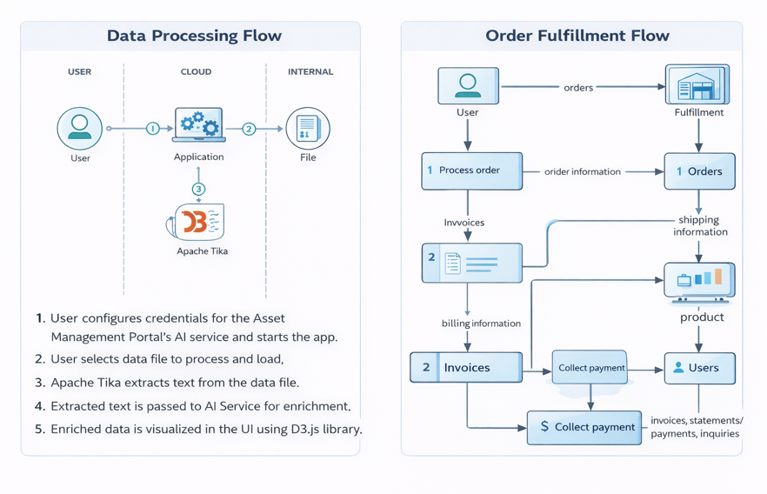
Data Flow Diagrams for Management Asset Portal:
A Data Flow Diagram (DFD) visually represents how data moves within the Management Asset Portal. It shows how asset information enters the system, how it is processed, where it is stored, and how it is displayed as reports or updates. A clear DFD helps in understanding the system flow and improving asset management efficiency.

